**A PROJECT BASED LAB REPORT**

**On**

**COURT CASE MANAGEMENT SYSTEM**

**Submitted in partial fulfilment of the**

**Requirements for the award of the Degree of**

**Bachelor of Technology**

**By**

**S.NO ID NUMBER NAME**

**1 160030291 D.Pushkar**

**2 160030432 G.Monika**

**3 160030870 Mohammad Syfullah**



**DEPARTMENT OF COMPUTER SCIENCE ENGINEERING**

**K L University**

Green Fields, Vaddeswaram, Guntur District-522 502

**2017-2018**

**K L University**

**DEPARTMENT OF COMPUTER SCIENCE ENGINEERING**



***CERTIFICATE***

This is to certify that this project based lab report entitled **“COURT CASE MANAGEMENT SYSTEM”** is a bonafide work done by **D.Pushkar (160030291), G.Monika (160030432), Mohammad Syfullah (160030870)** in partial fulfilment of the requirement for the award of degree in **BACHELOR OF TECHNOLOGY** in **Computer Science Engineering** during the academic year 2017-2018.

**Lab in Charge Head of the Department**

**K L University**

**DEPARTMENT OF COMPUTER SCIENCE ENGINEERING**



***DECLARATION***

We hereby declare that this project based lab report entitled **“COURT CASE MANAGEMENT SYSTEM”** has been prepared by us in partial fulfilment of the requirement for the award of degree “**BACHELOR OF TECHNOLOGY in “Computer Science Engineering** during the academic year 2017-2018.

I also declare that this project based lab report is of our own effort and it has not been submitted to any other university for the award of any degree.

**Date:**

**Place: Vaddeswaram**

**ACKNOWLEDGEMENTS**

My sincere thanks to Dr.Sridevi madam **,** in the Lab for their outstanding support throughout the project for the successful completion of the work

We express our gratitude to**,Dr. E. SureshBabu,** Head of the Department for Computer Science Engineering for providing us with adequate facilities, ways and means by which we are able to complete this term paper work.

We express our gratitude to **Dr. G. Krishna Mohan**, professor in-charge for computer science and engineering for providing us with adequate facilities, ways and means by which we are able to complete this term paper work.

We would like to place on record the deep sense of gratitude to the honourable Vice Chancellor, K L University for providing the necessary facilities to carry the concluded term paper work.

Last but not the least, we thank all Teaching and Non-Teaching Staff of our department and especially my classmates and my friends for their support in the completion of our term paper work.

**BATCH-17**

D.Pushkar – 160030291

G.Monika – 160030432

Mohammad Syfullah – 160030870

**CONTENTS**

1. Abstract
2. Introduction
3. Module description
4. Source code
5. Snapshots of the output
6. Advantages
7. Disadvantages
8. Conclusion
9. References

**ABSTRACT**

The project is about Court case management system. In this project court case consists of common attributes like judge, lawyer, convict, witness, any pending case on convict. These are common attributes for any case.so for every case we cannot call separate class so here we can use “Inheritance”, “Streams”, ”Files” and “Exception handling”. Here the information is common for every case we can inherit the properties of one class to another class by Inheritance principle. Here the super class is the Abstract class where we are going to call the attributes.

**The concepts used in the project is:**

Classes

Inheritance

Files and Streams

Constructors

Exception Handling

**INTRODUCTION**

A court case management system consists of the set of rules which must be followed to solve the case.

It is a method by which one can select the type of case like theft, murder, divorce, scams. Those are four cases we usually come across in our daily life. After selecting the case we have to select the lawyer and store the information like name, gender, age, details qualifications type of lawyer required etc.., these are common attributes for any client.

If case is theft we have to store the details like name, details, problem if any previous case on that client we have to tally the information after the case is completed. We have to store the information duration of punishment.

If the case is murder we have to store details like name, details, problem if any previous case on that murder we have to tally the details.

If the case is divorce we have to store the wife and husband information like name, details, problem and property issues can be cleared during the judgement.

If the case is scams we have to store the details like name, details, problem and how much amount that the client had scammed.

🡪**Platform Requirements:**

**Software Environments:**

The FMS software has (a) HTML as front end, (b) JavaScript for client side validation, (c) PHP for server side scripting, (d) oracle-9i as database and (e) Linux as operating system.

**Hardware Requirement:**

Minimum requirement for user side machine is that it should have Pentium-II or better configurations with 64 MB RAM and Web browser like Internet Explorer 5.0 and above.

**MODULE DESCRIPTION**

**AIM:-**  To write the JAVA code for the following program.

* Client details and type of case
* Lawyer and his/her timings
* Lawyer or Client information
* **Client details and type of case:**

Based on the type of crime or scams or any divorce judge or any other authority have to select the type of case. After selecting the type of case one has to enter the client details like Name, Gender, Age, Details, Problem by using Constructor.

* **Lawyer and his/her timings:**

Client has to check/select the available of the lawyer to one’s particular case. Based on the selected lawyer one has to wait for lawyer appointment, and his/her timings for the case issues. Also the opposite client arguments . Enter his/her client details in the file and also write the advisory report on that particular case. Client details are stored in the file format using Buffered Reader.

* **Lawyer or client Information:**

For displaying the stored information we have to choose lawyer or client. By using FileWriter we are reading the information from the client or lawyer. As there is no data stored before here we are Reading the data in the program by the files using Try block. The exception thrown by the try block is executed in the Catch Block. By using the console we are calling the data from the input file Stream.

**SOURCE CODE**

import java.util.Scanner;

import java.io.*;

class Pat extends Nit

{

int select;

Pat()

{

Scanner sc=new Scanner(System.in);

BufferedReader br=new BufferedReader(new InputStreamReader(System.in));

System.out.println("select your type of case");

System.out.println("1.theft");

System.out.println("2.murder");

System.out.println("3.divorce cases");

System.out.println("4.Scams");

int choice=sc.nextInt();

System.out.println("select your case");

int[] a=new int[10];

int count=0,x=0;

switch(choice)

{

case 1:for(int i=1;i<=8;i++)

{

if(d[i].branch=="theft")

{

System.out.print((count+1)+")");

count++;

System.out.print(d[i].name+" ");

System.out.print(d[i].clientid+" ");

System.out.print(d[i].qual+" ");

System.out.println(d[i].phn+" ");

a[x++]=i;

}

}

System.out.println("select the lawyer");

select=sc.nextInt();

System.out.println("timings of the lawyer"+d[a[select-1]].time);

String ilo=d[a[select-1]].name;

ilo=ilo+".txt";

System.out.println("enter details for appointment");

System.out.println("enter name");

String prob=new String();

String name1=new String();

prob=sc.nextLine();

try

{

name1=br.readLine();

System.out.print("enter problem");

prob=br.readLine();

}

catch(Exception e)

{

System.out.println(e);

}

System.out.println("enter age");

int age=sc.nextInt();

System.out.println("enter phone number");

String phn1=sc.next();

try

{

FileWriter w=new FileWriter(ilo,true);

name1="NAME:"+name1;

w.write(name1+" ");

w.write("AGE:"+age+" ");

w.write("PHONE:"+phn1+" ");

w.write("PROBLEM:"+"("+prob+")");

w.write(System.getProperty("line.separator"));

w.close();

System.out.println("appointment applied");

}

catch(Exception e)

{

System.out.println("not applied");

}

break;

case 2:for(int i=1;i<=8;i++)

{

if(d[i].branch=="murder")

{

System.out.print((count+1)+")");

count++;

System.out.print(d[i].name+" ");

System.out.print(d[i].clientid+" ");

System.out.print(d[i].qual+" ");

System.out.println(d[i].phn+" ");

a[x++]=i;

}

}

System.out.println("select the lawyer");

select=sc.nextInt();

System.out.println("timings of the lawyer"+d[a[select-1]].time);

ilo=d[a[select-1]].name;

ilo=ilo+".txt";

System.out.println("enter details for appointment");

name1="";prob="";

try

{

System.out.println("enter your name");

name1=br.readLine();

System.out.print("enter problem");

prob=br.readLine();

}

catch(Exception e)

{

System.out.println(e);

}

System.out.println("enter age");

age=sc.nextInt();

System.out.println("enter phone number");

phn1=sc.next();

try

{

FileWriter w=new FileWriter(ilo,true);

name1="NAME:"+name1;

w.write(name1+" ");

w.write("AGE:"+age+" ");

w.write("PHONE:"+phn1+" ");

w.write("PROBLEM:"+"("+prob+")");

w.write(System.getProperty("line.separator"));

w.close();

System.out.println("appointment applied");

}

catch(Exception e)

{

System.out.println("not applied");

}

break;

case 3:for(int i=1;i<=8;i++)

{

if(d[i].branch=="divorce")

{

System.out.print((count+1)+")");

count++;

System.out.print(d[i].name+" ");

System.out.print(d[i].clientid+" ");

System.out.print(d[i].qual+" ");

System.out.println(d[i].phn+" ");

a[x++]=i;

}

}

System.out.println("select the lawyer");

select=sc.nextInt();

System.out.println("timings of the lawyer"+d[a[select-1]].time);

ilo=d[a[select-1]].name;

ilo=ilo+".txt";

System.out.println("enter details for appointment");

name1="";prob="";

try

{

System.out.println("enter your name");

name1=br.readLine();

System.out.print("enter problem");

prob=br.readLine();

}

catch(Exception e)

{

System.out.println(e);

}

System.out.println("enter age");

age=sc.nextInt();

System.out.println("enter phone number");

phn1=sc.next();

try

{

FileWriter w=new FileWriter(ilo,true);

name1="NAME:"+name1;

w.write(name1+" ");

w.write("AGE:"+age+" ");

w.write("PHONE:"+phn1+" ");

w.write("PROBLEM:"+"("+prob+")");

w.write(System.getProperty("line.separator"));

w.close();

System.out.println("appointment applied");

}

catch(Exception e)

{

System.out.println("please try again");

}

break;

case 4:for(int i=1;i<=8;i++)

{

if(d[i].branch=="scams")

{

System.out.print((count+1)+")");

count++;

System.out.print(d[i].name+" ");

System.out.print(d[i].clientid+" ");

System.out.print(d[i].qual+" ");

System.out.println(d[i].phn+" ");

a[x++]=i;

}

}

System.out.println("select the lawyer");

select=sc.nextInt();

System.out.println("timings of the lawyer"+d[a[select-1]].time);

ilo=d[a[select-1]].name;

ilo=ilo+".txt";

System.out.println("enter details for appointment");

name1="";prob="";

try

{

System.out.println("enter your name");

name1=br.readLine();

System.out.print("enter problem");

prob=br.readLine();

}

catch(Exception e)

{

System.out.println(e);

}

System.out.println("enter age");

age=sc.nextInt();

System.out.println("enter phone number");

phn1=sc.next();

try

{

FileWriter w=new FileWriter(ilo,true);

name1="NAME:"+name1;

w.write(name1+" ");

w.write("AGE:"+age+" ");

w.write("PHONE:"+phn1+" ");

w.write("PROBLEM:"+"("+prob+")");

w.write(System.getProperty("line.separator"));

w.close();

System.out.println("appointment applied");

}

catch(Exception e)

{

System.out.println("please try again");

}

break;

}

for(int i=0;i<10;i++)

{

a[i]=0;

}

}

}

class Doc

{

String name;

String clientid;

String qual;

String phn;

String branch;

String time;

Doc[] d=new Doc[30];

Doc()

{

}

}

class Nit extends Doc

{

Nit()

{

d[1]=new Doc();

d[2]=new Doc();d[3]=new Doc();d[4]=new Doc();d[5]=new Doc();d[6]=new Doc();d[7]=new Doc();d[8]=new Doc();

d[1].name="p.siddardha";

d[1].clientid="123";

d[1].qual="llb";

d[1].phn="9701122517";

d[1].branch="theft";

d[1].time="10am to 5pm";

d[2].name="b.vinoothna";

d[2].clientid="124";

d[2].qual="llb";

d[2].phn="8333824902";

d[2].branch="theft";

d[2].time="11am to 5pm";

d[3].name="s.reetesh";

d[3].clientid="121";

d[3].qual="llb";

d[3].phn="9441589608";

d[3].branch="murder";

d[3].time="1pm to 5pm";

d[4].name="k.gopi";

d[4].clientid="126";

d[4].qual="llb";

d[4].phn="9848689058";

d[4].branch="murder";

d[4].time="10am to 5pm";

d[5].name="d.pavan";

d[5].clientid="127";

d[5].qual="llb";

d[5].phn="9701122517";

d[5].branch="divorce";

d[5].time="11am to 5pm";

d[6].name="A.jithendra";

d[6].clientid="129";

d[6].qual="llb";

d[6].phn="8333836103";

d[6].branch="divorce";

d[6].time="3pm to 5pm";

d[7].name="a.ritwik";

d[7].clientid="130";

d[7].qual="llb";

d[7].phn="7013099639";

d[7].branch="scam";

d[7].time="10am to 5pm";

d[8].name="s.reetesh";

d[8].clientid="131";

d[8].qual="llb";

d[8].phn="9701122517";

d[8].branch="scams";

d[8].time="8am to 5pm";

}

}

class Cou

{

Cou()

{

Scanner sc=new Scanner(System.in);

System.out.println("hello lawyer!!");

System.out.println("please enter your name in upper case");

String l=sc.nextLine();

l=l+".txt";

System.out.println(l);

System.out.println("enter the lawyers access password");

String pass=sc.next();

if(pass.equals("siddhartha"))

{

System.out.println("select option");

System.out.println("1.getdetails of clients");

System.out.println("2.logout");

int opt=sc.nextInt();

if(opt==1)

{

try (BufferedReader br = new BufferedReader(new FileReader(l)))

{

String line = null;

while ((line = br.readLine()) != null)

{

System.out.println(line);

}

}

catch(Exception e)

{

System.out.println("logout");

}

System.out.println("exit");

}

}

}

}

public class Javapro

{

int n;

Javapro()

{

Scanner sc=new Scanner(System.in);

System.out.println("who are you?");

System.out.println("1.client");

System.out.println("2.lawyer");

n=sc.nextInt();

if(n==1)

{

Pat p=new Pat();

}

else

{

Cou d=new Cou();

}

}

public static void main(String args[])

{

Nit n=new Nit();

Javapro j=new Javapro();

}

}

**SNAPSHOTS OF OUTPUT**

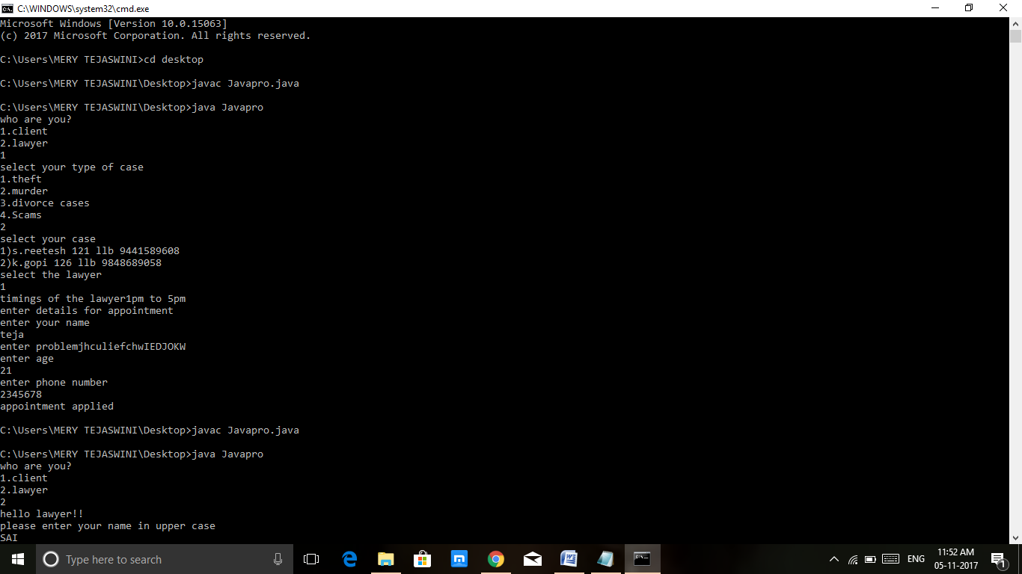

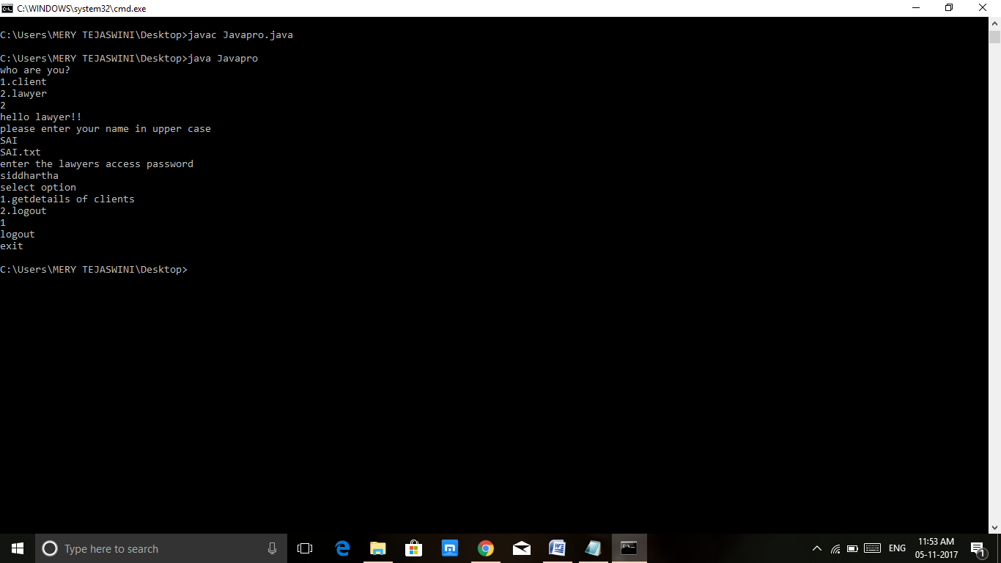

**ADVANTAGES:**

* Easy for registration of the case.
* Saving of time.

**DISADVANTAGES:**

* Need to have internet access.
* Not beneficial for uneducated people.

**CONCLUSION:**

From all the above modules we can easily know about the court case status management. In past we use to store the data of the client by maintaining records. By this program with little more implementation we can store the data of the client in data base which reduce the workload and also helpful in tally the data it also saves the time.

**REFERENCES:**

1. [www.enwikipedia.com](http://www.enwikipedia.com)
2. Text book for java reference by Schmidt
3. [www.javatpoint.com](http://www.javatpoint.com)
4. K.L.U Lectures.